# Artifacts

**The Cabin**

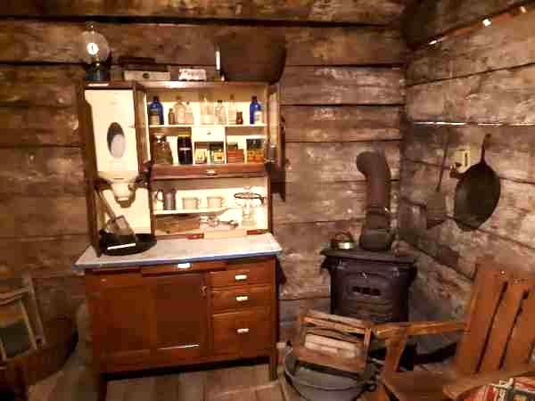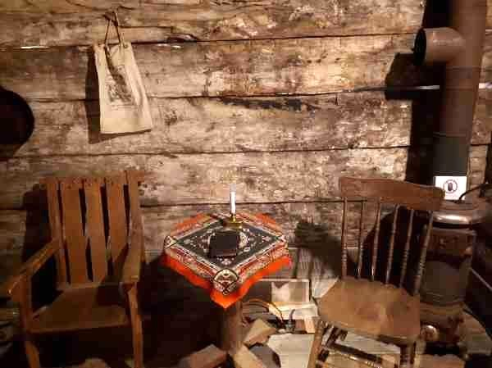The Norman Family Cabin was built by John Norman sometime during the 1880s, and was constructed using local fir logs. It was situated on district lot 3271 on a bench above the west bank of the Similkameen River, approximately 10 miles from Princeton, towards the town of Hedley. The lot was initially acquired by Tom Cole, who was married to the daughter of one of the First Nations leaders of the Similkameen, Chief Quinesco. John Norman married one of Tom Cole’s daughters and obtained the land through this union. The couple had two children together, a daughter named Kathryn Hayward and a second daughter of an unknown name, who died as a young girl, believed to be the result of consuming bear berries and milk. She is presumed to be buried in the family graveyard near Highway 3, as this is the original Anderson family home site. John later married Lily Allison, the daughter of John Fall Allison and Nora Yakumtekum, in Penticton and together they had 5 children: Maggie Duvall (Chuck), Grace Coyne (Tom), Leala

Anderson (Fletcher), Flora Haigh (Bob), and Jack Norman (never married). The couple lived in the cabin with their 6 children. The cabin was later donated to the Princeton Museum by three of Leala and Fletcher Anderson’s children: Gerald (Tip) Anderson, Myrt Anderson and Marg Anderson.

# Freeman Paintings

The Freemans owned a huge granite quarry at Lamorna, on the south-west corner of England. The business collapsed when a cheaper source of granite was developed in Spain. They sold their home in Falmouth, the house was called Carthion. The house is still here today in its present incarnation as the Carthion Hotel. They then moved to Princeton to start life over. The land in Princeton was grossly misrepresented to them by some real estate scoundrel. They thought they were moving to a beautiful arable valley, but the Similkameen River was nothing of the sort. It is a fast-flowing river that flows through a steep valley with boulders on either side, so their vision of life would be in B.C was completely removed from reality. The original Similkameen River painting by Winifred Freeman was donated by John and Amy Napier Hemy who inherited it when Peter Gregory, a former Similkameen police officer passed away. Winifred Freeman visited her nephew, Wilfred Freeman at his home in Princeton, British Columbia, around 1930 and during this time they painted together. The exact date she visited is unknown although one of her paintings titled “Canadian Winter” is dated for 1934. The rest of Winifred’s paintings are presumably in Great Britain in the Royal Academy of Arts and shared amongst her family. Wilfred Freeman was also a painter, his work was not as detailed or as artistically valuable as his aunt Winifred's but is still a record of history. Wilfred worked as a draftsman for local surveyor P.W. Gregory, drawing was his job but painting was his hobby. He is buried in the Princeton cemetery. Winifred's sister, Amy Mary Freeman, was married to John's grandfather, Charles Napier Hemy who is an internationally famous artist that is most famous for his marine paintings and paintings in the Tate collections.

# General William Sherman Sword

In August of 1883, US Army General William Tecumseh Sherman and a large contingent travelled through the Similkameen on his Final Inspection Tour before retirement. They came through the Similkameen Valley as there was no wagon road to the coast on the American side of the border at that time.

The history of General William Tecumseh Sherman's Sword as told by Susan L. MacGregor, February 26, 2016, story told to her by her grandmother, Susan L. (Moir) Allison.

“The history of Sherman’s trip to the Allison Ranch in the Similkameen, later Princeton, recorded and documented in the B.C. Provincial archives in Victoria. As Sherman had a troupe of several mounted men it was necessary to bivouac them separately to prevent overgrazing in any one spot on the ranch. My Uncle Jack, then a lad of 8, was delighted in being Sherman’s liaison between the troupes. Uncle Jack amused the General and his men by riding bare-back and often without even a brindle. Sherman was very impressed with my grandma who, always a lady, even in primitive surroundings, very graciously welcomed these American visitors despite having 9 children to care for. In the archival account Sherman recorded that “Mrs. Allison appeared a fresh-faced young lady of about 26, although she was the mother of 9 children.” He further said, and the family loves this quote - “it would appear the more inaccessible the district the more prolific the family”. Little did he dream that those 9 kids would have 5 more siblings.

Having discharged his duty in our area, the General mustered his troops to depart, having availed himself of the Grandparent’s hospitality, and their grazing pasture. His final act of gratitude was to present Grandma with a sword and scabbard. The scabbard has long since rotted but the sword remains in the family, being the property of my eldest son, D. Bruce MacGregor, presently living in Mayo, Yukon. At some point Grandma had given the sword and several other family artifacts to my Uncle George.

After his death his impoverished widow, Violet, about 1960, was trying to sell the sword, but she, not being well-informed, tried to flog it as General Grant’s. Naturally, there were no takers. Violet approached several family members but as she already owed them money, again, no takers. Among the items she was selling was an old pair of candlesticks that had come from the Moir (MacGregor) side of My family. These really interested my husband, Dugal MacGregor, so he happily made a deal with Violet to buy

the sword, the candle sticks (now belonging to my son Lorne), and a very old backgammon game box. (Witnessed and signed bill of sale is included in family papers). We gave the box to my cousin Ida Johnson Meldrum and its final destination is unknown to me.

The sword was loaned to the Princeton Museum. It did interest several American visitors, one of whom made a generous offer to purchase, which we declined, wanting to keep this memento in the family. To the best of my knowledge, this is an accurate account and can be verified.”

# Church Display

## Stained Glass

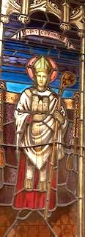The practice of decorating churches with stained glass can be traced back to 675 AD when Benedict Bishop ordered French workers to glaze the windows of the monastery of St. Peter in Great Britain. There are three pieces of stained glass that are part of the Princeton Museum collection, **“Saint Cuthbert”, “Saint Barbara”** and **“The Good Shepard”**. Saint Cuthbert (635-687) was a monk, bishop and hermit, associated with the monasteries of Melrose and Lindisfarne. He spent several years as a soldier in the service of the Kingdom of North Umbria before entering the monastery at Melrose. Legend attributes many miracles of healing and prophecy to Cuthbert during his lifetime. St. Cuthbert’s United Anglican Church was first formed in 1911 in Princeton, British Columbia.

Saint Barbara was an early Christian martyr and saint believed to have lived in Nicomedia (Turkey) or Heliopolis of Phoenicia (Baalbek, Lebanon)

during the third century. Her father tried to keep her away from Christianity as it was punishable by death. Legend states that when her father, Dioscorus, was away Barbara ordered three windows for her tower to honor the holy trinity. When he got back, he had Barbara tortured and then killed her for her conversion. After the execution Dioscorus was struck dead by lightning.

“The Good Shepard” was made in memory of Lillian Catherine Howse by her daughter Isobel Cattermole who was one of the founders of the museum.

## Gramophone

The Edison Wind-Up Phonograph was manufactured in circa 1900.

The phonograph in later forma was called a gramophone, and in the 1940’s people called it a record player. In early acoustic phonographs, the stylus vibrated a diaphragm which then produced sound waves which move to the open air through a flaring horn, or directly to the listeners ears through stethoscope-type earphones.

## Gulliford Family Pump Organ

This Gulliford family pump organ was purchased by Mr. and Mrs. Jack Gulliford at the turn of the century from the T. Eaton Company. In the 1903 catalogue it was listed for $29.50. The organ was dismantled in Merritt, British Columbia and brought here by pack train. It was left to their daughter, Lillian Susan Gulliford (Malech). Emma Carlson later purchased the organ and donated it to the Princeton Museum. train. It was left to their daughter, Lillian Susan Gulliford (Malech). Emma Carlson later purchased the organ and donated it to the Princeton Museum

## Geneva Bible

The Geneva bible is believed to have appeared in 1560 but not printed in England until 1575 and 1576. Over 150 editions were issued, the last was probably in 1644. In 2006 the first completely new publication of the Geneva Bible was published by Tolle Lege Press as part of the “1599 Geneva Bible Restoration Project”.

# Fossils and Minerals

## The Canadian Encyclopedia: British Columbia Eocene Fossils, David R. Greenwood

[British Columbia Eocene Fossils](https://www.thecanadianencyclopedia.ca/en/article/british-columbia-eocene-fossils)

During the early Eocene Epoch time period British Columbia had a subtropical climate. From the Princeton area north to Smithers there was an elevation of around 0.5 - 1.2km however there was a cooler upland region called the Okanagan Highlands, the amount of volcanic activity in this area created many lakes. The Okanagan Highlands was home to a vast number of mixed forests of coniferous trees such as cedars, firs, hemlock, redwoods, spruce and pine along with deciduous trees such as alder, birch, cherry, maple and sweet fern. The insects within this area were also very diverse which is expected in tropical forests.

## Joe Pollard

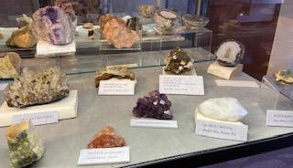Joe Pollard was born May 5th, 1919, in Vancouver British Columbia. In 1958 he began collecting minerals and fossils with his wife Shirley Pollard from Princeton, North America, and other places around the world. Joe kept precise records of these finds and housed them in cabinets that he built during the winter months. He was a

member of the North Burnaby Gem club, the friends of Mineralogy, the Fluorescent Mineral Club, and the British Columbia Paleontological Alliance. When Joe Pollard passed away in April of 1997 his 40,000-piece collection was donated to the Princeton Museum. The Pollard wing in the museum is easily one of the most extensive mineral and fossil collections in B.C.

## Fluorescence

Fluorescence causes a mineral to glow when exposed to ultraviolet light. Of the 40,000 mineral specimens in the Joe Pollard collection the most popular is the fluorescent mineral display. When short and long ray black light is shone upon them minerals such as calcite, fluorite, quartz and willemite glow and sparkle. Miners use the property of fluorescence to their advantage by using underground fluorescent lamps to identify and trace ore-bearing rocks. They have also been used on picking lines to quickly spot valuable pieces of ore and separate them from waste. Many gemstones are fluorescent such as ruby, kunzite, diamonds and opal.

## Fossilized Plants

Fossils can be formed in many different ways, but most are formed when a plant dies in a watery environment and is buried in fine-grained sediment such as sand, clay, silt or is in association with organic deposits. Good candidates for forming fossils are streams, flood plains, lakes, swamps and the ocean.

There are many plant fossils within the collection, some of these consist of birch, chestnut, willow, katsura and maple.

## Petrified Wood

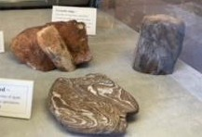Petrified wood is formed when woody stems of plants are buried in wet sediments saturated with dissolved minerals. The lack of oxygen then slowly decays the wood which allows the minerals to replace cell walls and fill void spaces in the wood. There are many pieces of petrified wood within the collection, some examples are wood replaced by chert, branch and twig impressions, wood replaced by coal and growth rings.

## Dinosaur Tracks

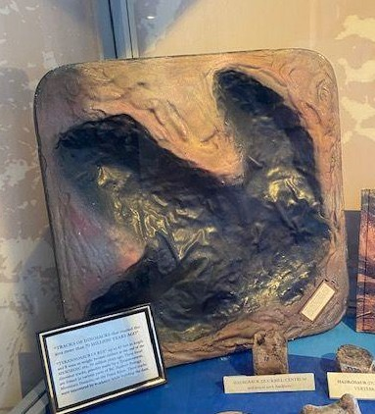The tyrannosaurus rex was up to 45 feet long and weighed 8 tons, it became extinct in the Mesozoic era, 70 million years ago. The fossil dinosaur tracks were possibly made by a tyrannosaurus and were also found in various parts of BC Hydro’s Portage Mountain Damsite, on the Peace River. They were uncovered by workmen while building the dam.

There were very few dinosaurs recorded in the Princeton area.

## Dinosaur Bones

The long dinosaur bone was discovered in sandstone at the Gordon Ranch in Kaycee Wyoming.

Most fossil bones found in Drumheller’s badlands are from Duck Billed Dinosaurs. They are about 70 million years old.

Some other bones in the collection are hadrosaur (duckbill), centrum and neural arch (backbone), theropod phalanges (meat-eater toe bones), theropod tooth and champsosaur vertebrae.

## Fossilized Insects

There are many insects within the fossil collection such as the wasp, water strider, march fly and spittlebug, which were all collected and donated by Joe Pollard. There is also a beetle, mystery insect and march fly.

## Scorpionfly Wing

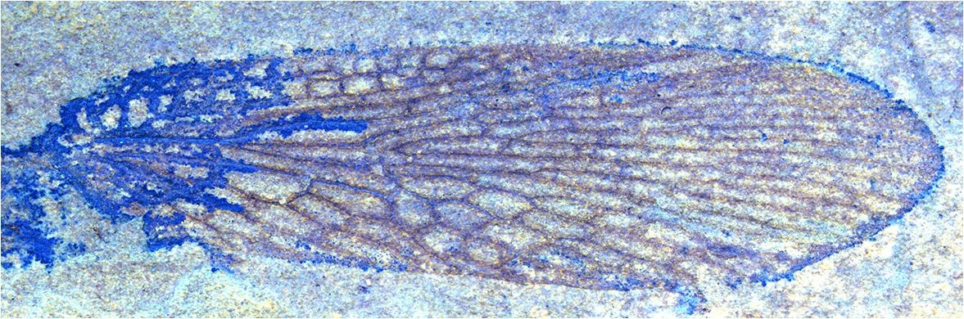This 50-million-year-old scorpionfly wing was found in Princeton in 2016 by Kathy Simpkins and represents a new species: Eomerope Simpkinsae. Being the only example of its species, the Princeton Museum donated it to the Royal BC Museum in Victoria for

future scientific study. Scorpionflies are now virtually extinct except for one species (Notiothauma reedi) living in the forests of Chile.

## Ammonites

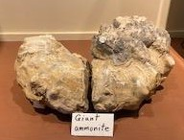Ammonites were sea creatures belonging to the phylum Mollusca and class Cephalopoda. They had a coiled external shell and may have lived a maximum of 400 meters deep in the ocean. Ammonites are now virtually extinct but are the most easily recognized fossil in the world. They went extinct at the end of the Cretaceous period, around roughly the same time the dinosaurs disappeared.

# First Nations Collection

“From first contact the influx of settlers was slow and yet steady, and both the Okanagan’s and settlers worked towards a living arrangement. It was understood that the Okanagan’s would continue to use their traditional hunting, fishing, and gathering grounds. As settlement of the Okanagan increased, the international border was established, and the colony of British Columbia joined confederation, considerable pressure was put on the provincial government to designate reserves for Native people”.

- Okanagan Nation Alliance

The First Nations Peoples of the valley lived in homes of two types depending on the season. The summer dwelling was cone shaped and during the winter months their homes were semi-underground and called pit houses. These pit houses were typically 12 to 14 feet in diameter, 6 feet deep and dug in a circular or oval shape. The pit houses would have a log frame, the walls and roof are covered in grass, sticks, bark and brush. People would live in pit houses in the winter because they provided warmth and shelter. Pit houses have been used over the past 12,000 years.

## Syilx Peoples

The museum and surrounding area are sitting on the Smilqmix territory, they are among the Syilx (also known as Okanagan) Nations, they “have been here since time immemorial”. The Okanagan Nation Alliance writes that “Yil” the root word of Syilx “refers to the action of taking any kind of many stranded fiber like hemp and rolling it and twisting it together to make one unit or one rope. It is a process of making many

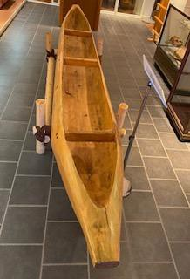into one”.

## Dugout Canoe

The canoe is on loan from the Upper Similkameen Indian Band. Herman Edward carved this canoe in 2003 out of a cottonwood tree using modern tools and methods. Dugout canoes were commonly used by the plateau First Nations as their primary means of

long-distance transportation and were typically made of red cedar or cottonwood trees due to their durability, strength and density. They remain an important part of Okanagan culture and continue to be

constructed today using traditional and modern methods. The canoe was most recently used in the water July 2020.

## Basketry

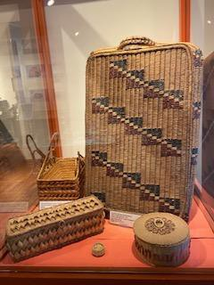The baskets were made of rigid and woven plant fibers, cedar root, splint material, tulle and cattail reeds and even ponderosa pine needles. Depending on their use's baskets came in a variety of shapes and sizes, they were commonly used for gathering, drinking, carrying and storing water, cooking, kettles, cradles and serving and storing food. There is indication of a heavy reliance on basketry for food and water storage as there is no archaeological evidence of pottery.

It is unknown where most of the basketry found within the Princeton Museum is from as it came from Sam Langford's collection.

The **Basket Weaving Awl** is made from deer bone and was found in the Lytton BC area. It was donated to the museum by Dan Bruce.

## Pictographs

Ochre was used in the making of the hundreds of pictographs found throughout the Similkameen Valley. Many scholars believe they were used to document territories, significant historical events, or images formed in a vision quest.

[HistoricPlaces.ca](https://www.historicplaces.ca/en/rep-reg/place-lieu.aspx?id=14552)

“Along the old trail route, between Tulameen and Chuchuwayha, lie dozens of pictograph sites, marking the place where young men and women fasted and prayed to the spirits, and where representations of dreams and guardian spirits were painted upon the rocks. Red, orange and yellow ochre taken from the Tulameen Ochre Bluffs was used as a paint to create substantial pictographs, which date from around 4000 years ago. The ochre was also used for spiritual and ceremonial purposes, for decorating clothes and other items, and making face and body paints.”

**Princeton Our Valley Pg. 13**

The Similkameen valley is rich in pictographs. They are found chiefly along the old Hedley Road, and it is not known how old they are. The materials used in order to make these pictographs were red ochre mixed with root juices and the fats from animals.

During the summer of 1932 – 1933 many of the pictographs were in danger of being destroyed while roads were being reconstructed. There are at least 20 sets of paintings between Princeton and Hedley on the old road, it is difficult and if not impossible to interpret these paintings. Many of the larger ones may have been the work of several artists, some may have been undergoing a long vigil, others may have been messages.

## Ochre

[**The Red Rocks and Blue Waters of Princeton, BC**](https://www.tothewild.com/the-blue-waters-and-red-rocks-of-princeton-bc/)

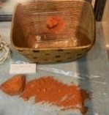Ochre is spiritually important to many First Nations people. It inspired the early name for the Princeton area, Vermilion Forks, as well as Tulameen, as the Smilqmix work for “ochre” is “Tul-mn". Ochre is a natural clay earth pigment made of a mixture of ferric oxide and varying amounts of clay and sand. It ranges in color from yellow to deep orange or brown.

The different colors of ochre brought First Nations people from around the West, some colors that can be found here are orange, yellow, brown and black. It may be the only place in North America that has all these colors within one area.

## Obsidian



Obsidian is a volcanic glass that is created when magma is pushed to the earth's surface and then cooled very rapidly.

It was traded extensively among First Peoples in North America and around the globe due to it having an extremely sharp edge.

Obsidian was used to make arrowheads, knives, spear points,

scrapers and many other weapons and tools. As obsidian cannot be found locally the

alternative in the area is chert, chert is a hard, dark, opaque rock composed of silica with a microscopically grained texture. Chert could be used to make weapons, like arrowheads and ax heads, it was very hard and durable, and the edges were very sharp.

## Scrapers

Scrapers were typically used in the process of scraping hides or wood. Common scrapers were large enough to comfortably hold in one hand, others were smaller and notched in order to be affixed to a handle.

## Canoe Bailer

The canoe bailer is from Sam Langford’s collection, there is not much information on it other than the fact that it is made from cedar bark with a wooden handle. A canoe bailer is typically used to bail out water if it is taken on in the canoe.

## Drills

These drills are from the Thompson-Okanagan region. They were either hafted (attached to a handle) or used by hand to perforate hide, bone, stone, and wood.

## Sun Sign Buckskin Dress

This buckskin dress was created in 1912 and donated to the Princeton Museum by Mary Snowden. The sun sign symbol has been used in many different cultures around the world for thousands of years. The sun symbol, also known as the swastika in other cultures, represents divinity, and spirituality in some cultures, but is also a sign of good luck and the sun.

## Lithic Tools

First Peoples used stone, bone or antler to break or grind away pieces of rock to craft complex tools such as drills, arrowheads, spearpoints, scrapers and blades. This process is known as knapping and is still practiced today. While much of the stone used to make these tools was sourced locally, some would have been acquired via trade with people of other Nations.

## Medicine Man Mask

The medicine man mask is from the Skeena River region in B.C and was purchased from the Sam Langford collection.

# Ranching

## John Fall Allison

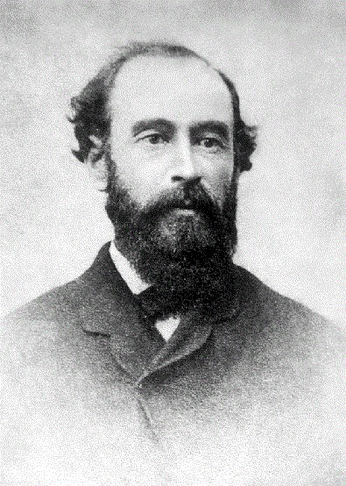In 1858 John Fall Allison settled in the Princeton area and became the first European settler. By the end of the 19th century the grasslands and open woodlands of the valley bottom were divided up into ranches.

## Karl Freding

Karl Freding was born in Princeton BC on November 19, 1916. He was raised on his father's homestead near Princeton and worked on nearby ranches until 1938 when he and his brother bought some abandoned neighboring properties and struck out on their own. After marrying Margaret Allison, a local rancher, he bought out his partners and raised commercial cattle and wheat. In 1946 he bought his first registered Hereford cow which was the beginning of Karl and Margaret Freding’s Rafter F Hereford Ranch. Their ranch became a leader in the industry for nearly half a century selling many championship Hereford bulls at both Kamloops and Williams Lake bull sales. After selling their ranch in 1992, they retired to Osoyoos where Karl continued to manufacture the popular Ty Ten Lok wire gate closers that he had invented and patented. The rights were eventually sold, and versions of the device are still available today.

## Kenny McLean Saddle

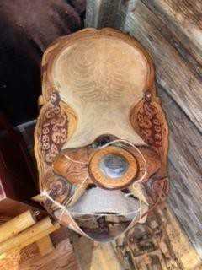[Kenny McLean](https://bcsportshall.com/honoured_member/kenny-mclean/)

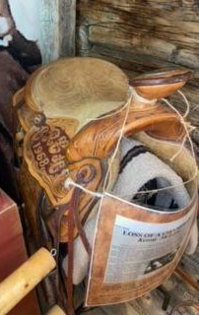Kenny McLean passed away from a heart attack on July 13, 2002, at the age of 63 in his saddle on Last Wish, his rope horse, while waiting for a senior roping event at a rodeo in Taber, Alberta. He was born the youngest of 10 children in 1939 in Penticton and grew up in Okanagan Falls on a ranch at the south end of Skaha Lake. By age 12 he was breaking in colts for his father and by age 17 he entered in his first rodeo, riding in a bareback event at an amateur rodeo in Keremeos. In 1958 he won his first BC amateur bronc riding championship, by 1959 he turned professional and won his first Canadian saddle bronc championship, he won this title four more times after that year and was the first Canadian cowboy to win the title three years straight and five years in total. In 1961 he turned to the Rodeo Cowboys Association (now known as the Professional Rodeo Cowboys Association), he scored points with the judges and baffled his competitors. Kenny McLean finished fourth overall in the bronc riding standings and was named PRCA’s rookie of the year, this won him a massive six-foot-tall

trophy that continues to reside as the largest trophy in the BC Sports Hall of Fame collection. It was estimated that he won 41 prize saddles, 15 watches, over 100 trophies, nearly 200 assorted prize buckles, belts, spurs, rifles, boots, hats, silver trays

and of course, prize money. Kenny McLean spent 10 to 12 years in the Princeton area training horses and mentoring younger people who were also interested in horses.

His saddle was donated to the Princeton Museum by Mr. and Mrs. Dave Atkinsons who were gifted the saddle before McLeans passing in 2002.

## Willard Albert “Podunk” Davis

Willard Albert was born in 1859 in Louisville Kentucky and passed away in 1943 in Princeton, British Columbia. Podunk earned his nickname at an early age, in South Dakota, when he helped capture jewel thieves and recover the stolen goods. Willard had been hiding in a haystack when he overheard the thieves and saw where they hid the jewels. He reported what he saw to the local Sheriff who called him “Podunk” in reference to Detective Podunk, a character from the popular dime novel series *Deadwood Dick*.

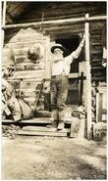Willard was rewarded with a ruby ring from the jeweler whose store had been robbed. He cherished this ring throughout his life. Podunk Davis gained wide fame again in the mid-1920s when he found and rescued Nurse Mary Warburton who had been lost for weeks while hiking in the Cascade Mountains between Hope and Princeton. John Oliver awarded Podunk the Royal Humane Society's *Bronze Life Saving Medal* at a ceremony held in Princeton in April of 1927. Podunk spent his life in the wilderness of the Cascade Mountains in which now, Mount Davis and Podunk Creek in the headwaters of the Tulameen, bear his name. One of his saddles can be found in the museum.

<https://arcabc.ca/islandora/object/princeton%3A1926> - picture of Podunk Davis at 12-mile cabin

**Luke Gibson** was one of the most successful race horse owners in the province in the 1920’s. His ranch was located just above the Jura schoolhouse. He ran horses at almost all of the major tracks on the North American continent but also took them all the way to Cuba, Mexico and New Orleans. During one season, at Bright house on the Coast, his horses won many first prizes. It appears Luke raised more good B.C. horses than perhaps any other breeder in the province at the time.

Some other early ranchers are **Mr. Rabbitt**, he owned a large ranch which Coalmont Collieries purchased from him and it is now the townsite of Coalmont. **Gordon Sellers** who preempted 320 acres of land at Summers Creek in 1919, he also rented the Old Guinan Ranch from 1912 - 1920, it was purchased by Wayne Sellers in 1939 when the family moved to the Princeton area. **Mrs. Vaughan** raised lamb at Osprey Lake before selling to Sarich’s

# Mining

Gold and Copper were the first metals discovered by man around 5000 BC. Copper is the third most abundant mineral found in the Princeton area and has been extracted here since the 1920’s. Ten kilometers from Princeton, at Copper Mountain, a community developed following the development of the underground mine, at its peak it had 600 inhabitants. In 1957 this mine was abandoned in favor of an open pit operation, many of the dwellings were sold, dismantled and moved.

**Copper Mining**

Copper mountain is located 12 miles from Princeton, and despite other nearby locations, has proved to be the only major producer of copper in the area. Copper was first discovered by John Fall Allison on the “Hope Road” in 1859, in the vicinity of Kennedy Lake, and the discovery of Copper Mountain quickly followed, dating back to 1888. According to local folklore, James Jameson and his father were out hunting, when a deer presented itself; both men shot and the deer went down. As they approached, however, the deer jumped up and ran off into the woods. While searching for the deer, the father observed some copper outcroppings and made known his discovery to one R.A. Brown, who staked the Sunset Claim in 1895. In 1905, the BC Copper Co. took options on a number of claims, including the Sunset, and although the results were initially discouraging, by 1913 the ore treatment problems were solved by the discovery of a new process, and the camp was developed. Over the decades, the mine has started and stopped production multiple times in accordance with fluctuating copper prices. The mine reached its lowest during World War II, bringing in only 2580 tons per day. As of 2021, an expansion plan is in place that would increase the production of Copper Mountain Mine to 65,000 tons per day.

## Copper Mountain Mine Model

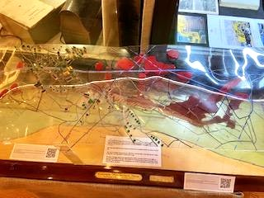The model of the Copper Mountain mine was made between 1948 and 1949, primarily by Frank Burgess, Harry W. Day and Keith Fahrni. The plexiglass ‘surface’ was formed with difficulty over the assay office hot places, and while not exact the topography is fairly accurate. Over time the model has been bemired, cleaned and reassembled, and is now nearly 60 years old. The ‘red’ ore bodies were proven ore, while those ‘red and white’ were inferred ore. Copper at this time was in the

$0.22 to $0.25/lb. price range. The mine workings ranged from approximately 4200 feet elevation, down to level eight at approximately 2835 feet elevation. The number two shaft bottomed at approximately 2760 feet elevation. The Similkameen River dump house was at 2615 feet elevation, and the water tanks were at 4200 feet elevation.

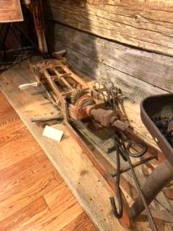The Copper Mountain Mine was changed into an open pit mine in 1979 and the houses were taken down.

## Rock Drill

The rock drill was used to drill blast holes in rocks for mining or construction purposes. Holes would be filled with dynamite or other explosives, they were prepared in patterns to achieve the most efficient blasting results.

## Mine Rescue Trophies: Granite Creek

These trophies were entrusted to the Princeton Museum in 1978 by the

Department of Mines. There are a total of 13 trophies including the Miners First Aid Cup

– Department of Nicola-Similkameen, which was first competed for in 1916. Most of the trophies were last competed for in 1953 – 56 which were the final years of the Granby Mining Company in the Princeton area.

## Miners Safety Lamp

This lamp provides illumination in coal mines and is designed to operate in air that may contain coal dust or gases, both of which are potentially flammable and explosive. It was often carried by the fire-boss.

## Mining Scale

The mining scales were used to weigh what the miners found. Gold commissioners scale P 965.68

Other mining items within the museum consist of maps, photos, mining tools, mining hats, surveys, drills and bits, a rescue kit, respirators, helmets, lamps, an explosives detonator from circa 1930, Allenby foundry pamphlet, and a Granby car advertisement.

# Logging

Some common trees found in the area are Douglas Fir, Ponderosa Pine and Lodgepole Pine.

The Okanagan lumber industry started at about the turn of the century, following the bustle of railroading and then supplying dimension lumber for local construction.

Gradually an export lumber industry began to build.

The logging industry has played a large part in the development of Princeton’s history. Names recorded in the annuals, but now long gone, include Kettle Valley Lumber Company, Taylor Lumber Company, Huff Brothers Sawmill, W.T. Squelch and Son of Tulameen.

## POV Pg. 66

**Huff Brothers Sawmills Ltd., Princeton BC**

Brothers **Charlie, Henry** and **Roy Huff** added mixed ranching, farming and mining to the sawmill business they started in 1942. They sold their main sawmilling interests to Northwood in the late 60’s but continued to saw timber from private forestland.

## Kettle Valley Lumber Co. Ltd. - The Munsie Family

**Jack Munsie**, who served as ILMA President in 1962 – 1963 opened a mill in 1947 at Summers Creek, five miles north of Princeton. Munsie operated Kettle Valley Lumber Co. until 1966 when it was sold to Nicola Valley Sawmills Ltd. Munsie passed away in 1988 and was an active supporter of the Canadian Forestry Association. He was married to Dorothy who continued to reside in Princeton after his passing.

## Taylor Lumber Co. Ltd. - Jack Taylor and Sons.

Taylor Lumber Co. Ltd was incorporated in 1938 after **Jack Taylor** and sons **Graham**, **Norman, Bert** and **Bob** took over a bankrupt sawmill on the Abe Willis property in Wolfe Creek, east of Princeton. They moved this mill to a site near the present Princeton golf course, where they continued to operate for 28 years. After Jack died in 1961, his sons operated the mill for five years before selling to Nicola Valley Sawmills Ltd.

## W.T. Squelch and Son Ltd., Tulameen

**W.T Squelch** opened the mill in 1947. His son, **Grant**, had worked for Fraser Mills at Maillardville before relocating to the interior. Father and son added a planer to their operations in 1954. In the late 50’s they sold to Oliver Sawmills, who closed the mill in 1960.

## Western Pines Lumber Co. Ltd., John Nylund

**John Nylund** was a sawmiller who arrived in the Princeton country from Grants Pass, Oregon in the 50s. He ran a planer mill located near Princeton, supplied by portable mills at Glimpse Lake, near Merritt, and Beacon Flats in Princeton. The portables were shut down in 1956. Nylund built his own mill in east Princeton, on the site of the existing Weyerhaeuser Canada Ltd. Mill. He sold to Northwood Mills in 1963 and it continued to operate under its existing name until Northwood amalgamated its area operations in 1967. Northwood sold the mill to Weyerhaeuser Canada in 1978.

## McInroy Sawmills, family operation

Located seven miles east of Princeton, on the north side of the Similkameen River, McInroy Sawmills was owned by **Howard McInroy** and sons **Clarence** and **Gavin**. The company was an ILMA member until sold to O’Neil and Devine Ltd., of Merritt. Howard and Clarence McInroy are deceased. Gavin still operates the family sawmill in its original location (2000).

## Tree and Log Scale Stick

The tree and log scale stick were used to determine the amount of lumber in a given log or tree, according to a particular standard.

# Blacksmith Tools and Collection

## Champion 400 Blower & Forge Co. Lancaster PA. USA Model

This was used in a fair number of small blacksmith shops to forge iron into tailor shaped horseshoes, tools and various other things. This device was usually hooked up to a forge table by a pipe that would funnel the air under the table to heat coals. These coals

would then heat up the metal that the blacksmith was going to bend and shape. This forge was patented in June and July of 1901

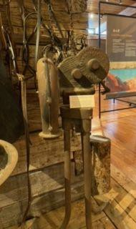

## Portable Forge

The portable forge was used for the same purpose as the large forge but was meant to be portable. They were typically sold to hobby smiths, home mechanics, farmers and miners for sharpening drill steels in the absence of a blacksmith. Eric Jacobson donated this to the museum in 2000.

## Tongs

Blacksmith tongs were used while working with hot steel, many different types of tongs were required for holding the work securely on the anvil as it was being forged. Blacksmiths used the tongs for transferring the hot steel and metals, to lower the chances of getting hurt/burned.

## Rivet Hammer

A blacksmith would have used a rivet hammer to attach pieces of iron together with rivets. A hole would be made in the iron and then the blacksmith would use a hammer to make the heads at each end.

# Trapping

## Red Fox (Vulpes Vulpes) Pelt

Due to their large population and range of distribution, the red fox played a key role in the fur trade of the nineteenth century in this area.

There are a variety of other pelts as well such as otter, marten and muskrat.

## Trapping

The Hudson's Bay Company went from Otter Lake straight to Merritt and on to Kamloops with the furs. Trapping was a big part of life in the area and there are still families with trap lines in Princeton.

In the early 1800’s fur trading began in Western Canada. In June 1846, Alexander Caufield Anderson undertook the first recorded trip through the Cascade Wilderness seeking a new route for the Hudson’s Bay Company. Anderson’s goal was to link Fort Kamloops with the Pacific Ocean without crossing the 49th parallel as the new US boundary blocked access to the HBC’s previous route. The path followed by the Hudson’s Bay Company 1849 Brigade Trail was originally a hunting, fishing, gathering and trade route used by the First Nations people of the Similkameen.

Blackeye of the Similkameen and his son were the ones to show Anderson the shorter, easier route over the Tulameen Plateau. For more than a decade, the HBC’s fur empire depended on this route. Nora Yakumtikum, daughter of Chief Quinisco of the Similkameen and first wife of John Fall Allison, ran a pack train along the HBC. this resourceful woman also ran an express mail run from the HBC to Princeton and Keremeos using an HBC provision restocking spur.

# Ice Harvesting Tools

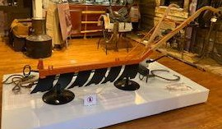Nathanial Wyeth of Boston is credited with inventing the ice plow in 1825. It was drawn by horse and made of cutting teeth fitted in a straight line, each tooth being slightly longer than the one in front of it. An ice plow with short teeth was called a marker plow and was used to mark the area in a grid pattern. Between 1915 and 1925 each winter for approximately 2 weeks fresh ice was harvested from Otter Lake in Tulameen. The Great Northern

Railway then transported the majority of the ice to the many ice houses west of Spokane, Washington. One harvest required 3000 rail cars to transfer the ice that it took several hundred men to cut in less than 2 weeks. From 1925 to 1938 Otter Lake continued to be a source of fresh clear ice for local use as fresh water and refrigeration. As refrigerators and freezers began making an appearance in southern BC in the late 1930’s ice harvesting soon disappeared.

The ice business in Princeton was initially run by Bill Garrison until being sold to Mr. Gerald Harker, father of Len and Roy who restored and donated the Ice Plow.

# Pioneer Household Items

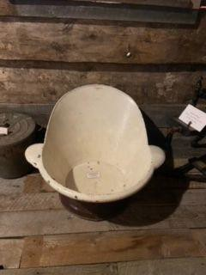Some pioneer household items consist of wash tubs, scrub boards, a cook stove with cast iron, a kettle, stove items, tins, a butter churn, a wood bowl for bread/butter making, cookbooks, an old water pump, various pieces of period furniture, glass bottles, an old phonograph and records.

## Sit-down Bathtub

The sit-down bathtub was made circa 1851 in India and is also commonly known as the Sitz Bath. It is located within the cabin.

## Breadmaker

The tin bread maker located around the cabin is from circa 1904. It is the

No. 8 Universal Bread Maker by Landers, Frary and Clark of New Britain, Connecticut. It won a gold medal at the St. Louis Exposition in 1904. The advertisement for Universal at the time stated that making bread with their machine was superior to hand kneading.

## Old Water Pump

The James Smart Manufacturing Co. Ltd. water pumps could typically be found mounted on dry sinks in the home as they could be made smaller in size. The handle for the pump was closer to the front than normal which allowed the pump to be mounted for inside use. When pumped they would bring water up from a cistern under the house. These were used from around 1860 to the early 1960s.

## Whiskey Still

The process of distillation works around the principle that alcohol has a lower boiling point than water. When the distillate, which would be corn mash in the case of making whiskey, is heated above the boiling point of alcohol, but below the boiling point of water the alcohol begins to evaporate. The alcohol vapors are then captured and cooled back to a liquid form and collected for consumption. This whiskey still is from Podunk Davis’ Cabin.

# The Granite Creek Hotel

## Owl Slot Machine

The Owl Slot Machine was manufactured by Mills Novelty Co. in 1897. It was the first mechanical upright cabinet slot machine, it proved to be more reliable and convenient than the earlier battery-operated electric models.

# Princeton Brewery

The location of the Princeton Brewery was a popular destination in the area long before the brewing company arrived; this is because the Brewery was situated in the same spot as the Vermilion Cave. The creation of the cave was thanks to the geological foundations underlying the town of Princeton. The town sits on sedimentary rock from the Eocene epoch, which happened 56 to 33.9 million years ago. The caves themselves were made of sandstone, a sedimentary rock consisting of minerals the size of sand granules. Sandstone beds often form cliffs and bluffs that stand out from the surrounding landscape. Sandstone caves such as the Vermillion Cave are formed by long-term erosion from wind or water that carves out cavities in the stone. Despite sandstone caves often being shallow; according to historical accounts, the Vermillion Cave was exceptionally large. The cave was a haven for First Nations people for centuries, and the first Europeans to arrive in the area frequently sheltered in it, giving it

the reputation of Princeton's first hotel. Later, the cave was used by the brewery as a storage space for aging beer, and was apparently massive enough to hold 24 freight carloads of lager. Some even believed that aging the Princeton beer in the "Old Cave" was what gave it such a fine flavor. Sadly, in 1948, the cave was demolished to make way for the Hope-Princeton Highway, and a geological and historical treasure was lost in the name of progress.

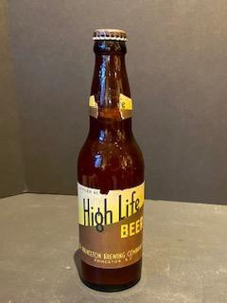In 1913, the Princeton Brewing Co. was established from the old Nelson Brewing Co. after its Hedley brewery was moved to Princeton. In 1933, a new

plant was built at the site of the present Billy’s Family Restaurant. At this site, there was a cave that was used to store bottles and other articles. The Brewery was in operation until 1961 when the company was bought by the E.P. Taylor group (Canadian Breweries). In June 1961, the last shipment of beer was made in Princeton and the equipment was moved to the Ben Ginter Brewery at Prince George, and the buildings were demolished. The beer used to be shipped from Princeton to as far north as Whitehorse and Dawson Creek during

WWII. Wooden barrels were used, with individual bottles encased in a ‘sleeve’ holding 13 dozen bottles per barrel.

Some items from the Princeton Brewery consist of the whiskey barrel, bar shakers on the stand and Princeton Brewery beer bottles.

Some of the glass bottles in the collection are from the Princeton Brewery and others are miscellaneous from various periods.

# Tashme Internment Camp

The Sunshine Valley or the area between Hope British Columbia and the start of Manning Park used to be called Tashme, it was an unincorporated settlement and Japanese internment camp. The internment camp was considerably large and housed around 2400 Japanese Canadian citizens. The men in the camp were employed to build the highway going through Manning Park during World War II. They used hand tools such as shovels, picks and wheelbarrows to slowly build the highway.

[Tashme Internment Camp](https://onthisspot.ca/blog/tashme)

2,600 Japanese people were crammed into primitive and unsanitary shacks at Tashme during the harsh winter of 1942-43. They would remain there for the remainder of the war. When the war ended in 1945 however, they were still forbidden to return to their homes. Indeed, they had no homes to return to: the government had seized all their property and sold it off at bargain basement prices. The government encouraged them to move to eastern Canada and leave British Columbia altogether. The ban on Japanese-Canadians living on Canada's West Coast remained in place until 1949, four

years after the war had ended--proof that internment had more to do with racism than military necessity.

## The Bench

The bench was found in an abandoned building that was once part of the Tashme Internment Camp. The desks and benches were sent from the Vancouver Japanese language School to Tashme for use by the internees. The furniture dates back to the 1930’s

# Railways

## Victoria Vancouver and Eastern

The construction of the V.V. & E. into Princeton was part of the route which James Hill planned on building between Spokane, Washington and Vancouver B. this railway was all part of the Great Northern Railway of the United States which operated in Canada under the name “V.V. & E”. The railway came from Keremeos to Princeton, a distance of 41 miles. The line was opened December 23, 1910. During 1911 grading was underway from Princeton to Coalmont and to Tulameen.

## The Great Northern

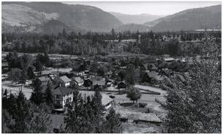Mileposts: British Columbia, Great Northern in Retrospect Railway By 1907, Jim Hill’s Great Northern Railway had crossed the International Border along British Columbia’s southern interior at 10 different locations. At its peak in 1915, GN had over three hundred route miles of track in the southern interior of B.C and

many more miles of complementary trackage just below the International Boundary. The GN-CPR rivalry produced many more miles of railway than the region could support and it was inevitable that abandonments would result. The 1930’s saw further abandonments and by the end of the decade GN was only operating 100 miles of trackage in the southern interior of BC.

## The CPR & KVR Railways

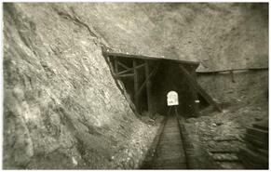 [**https://www.kettlevalleyrail.org/about/**](https://www.kettlevalleyrail.org/about/)

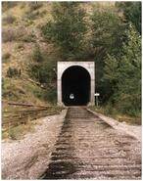In the 1890’s the CPR extended their service to the South Okanagan and constructed the Shuswap and Okanagan Railway from Sicamous on the CPR Mainline through to Okanagan Landing on Okanagan Lake. The Victoria, Vancouver and Eastern Railway, a subsidiary of the Great Northern Railway arrived in Keremeos in 1907 and in Hedley and Princeton two years later. The Kettle Valley Railway was born and survey work began in 1910 from Midway to Penticton and Penticton to Merritt, a year later work began to go through the Coquihalla pass. In January 1964

the final passenger run was made and eight years later the subdivision from Midway to Penticton was shut down. There were branch lines being added to the KVR mainline at the end of WWI, a spur constructed from Princeton to the mines at Copper Mountain and another eight-mile link line was added in 1930 from Penticton to Okanagan Falls. The CPR officially took over the KVR operations in 1930. Freight continued to run from Okanagan Falls to Spences Bridge until 1989.

<https://arcabc.ca/islandora/object/princeton%3Aphotographs?page=49> Photos taken from this website.

## Railway Pioneers

**James Jerome Hill** was born on September 16, 1838 in Eramosa Township, Ontario. He was a Canadian-American railroad executive and the chief executive officer of a family of lines headed by the Great Northern Railway. These lines served a substantial area of the Upper Midwest, the Northern Great Plains and Pacific Northwest. Due to the size of this region and the economic dominance exerted by the Hill lines, Hill became known during his lifetime as *The Empire Builder*. James was married to Mary Theresa Mehegan and had 10 children. He died on May 29, 1916 at the age of 77 in Saint Paul, Minnesota.

**William Cornelius Van Horne** was born February 3, 1843 near Frankfort, Illinois, he moved with his family to Joliet, Illinois, when he was eight years old. He began working on railroads in 1857, serving in various capacities on the Michigan Central Railway until 1864, then for the Chicago and Alton Railway for whom he served as the general superintendent from 1878 - 1879. In 1882, he was appointed general manager of the Canadian Pacific Railway, and in 1884 became its vice-president. Rising to president in 1888, he is most famous for overseeing the major construction of the first Canadian transcontinental railway. He died September 11, 1915 at the age of 72 in Montreal, Quebec.

## Kettle Valley Railway Time Table

The Kettle Valley Railway Time Table was published in the Princeton Star on Thursday April 28, 1927. It has the daily eastbound and westbound schedules as well as the Brookmere-Merritt schedule.

# Hospital Collection

April 7, 1900 - June 30, 1904

**W.A. Whillan, MD** arrived in Princeton sometime in the latter part of 1900. He built a house on Bridge Street and then later on Kenley Avenue. He also received an assistance allowance of $300 a year from the provincial government. On June 9th, 1900 Dr. Whillans called in both Dr. McPhail and Dr. Sutton to help perform what was undoubtedly the first surgery in the Similkameen. Appendicitis was rare anywhere in those days, the appendectomy was performed in Dr. Whillans office and was successful.

January 1, 1905 - April. 29, 1909

**Dr. JE Schon, MD.** came from Greenwood December 21, 1904, where he was Provincial Health Officer for that district. He served as a surgeon with the British Army. He later moved to Vernon.

In July of 1910 the hospital construction contract was awarded to A.E. Irwin for $5000, by the fall of 1910 the Princeton Hospital Auxiliary was formed, the first fundraiser was held on New Year’s Eve and raised $360.65.

**Dr. Daniel McCaffery** was born in Madoe, Ontario in August 1880. He moved to Princeton in 1915, where he practiced medicine until the early 1940’s. “Doc” served Princeton, the town of Copper Mountain, Allenby, Blakeburn, Coalmont and indeed the entire region. He travelled by car where he could, and if not then on horseback.

He married the second matron of the Princeton Hospital, Arletta Maude Faulds and together they had three children: John George, born October 1914, died March 1915, and is interred in the Princeton cemetery. Merla Jean, born January 1920, and died 2009, Audrey Elizabeth, birth and death dates unknown, but she attended teacher training at UBC in 1941 and is married with 4 children, Jenny, Danny, Alan and Sean. “Doc” retired to Nanoose Bay, on Vancouver Island and died in April 1960.

“As a point of interest, I remember a story that “Doc” had been forced at gunpoint to remove a bullet from the outlaw and train robber, Bill Miner”.

Submitted by Descendants:

Dan and Vince Metcalf, Brad and Jason Metcalf and Paige Metcalf

The hospital was informally opened on February 1, 1911. **Mabel Morrel (Thomas)** was the first Matron at the Princeton hospital, she was employed February 15, 1911, she left to serve in a field hospital in France in 1914. **Miss Faulds (Mrs. D. McCaffery)** became the second Matron in Princeton in 1914.

In 1924 **Mabel Burr** joined the Auxiliary and served for 56 years.

On October 19th, 1961 a new $20,000 Princeton Health Centre was officially opened by **Mrs. Paul Phillips** of New Westminster, widow of the late Dr. Paul Phillips. Over 150 guests visited the Health Centre facilities where 1800 square feet of office space is provided for a public health nurse, sanitarian, clerk, well-child conferences, visiting clinics and voluntary health agencies.

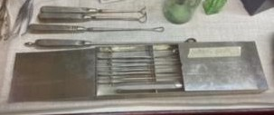Some hospital equipment in the collection consists of a medicine case with vials, surgery tools, amputation blades, and photos of the old Princeton hospital.

## Emerson Resuscitator

The Emerson Resuscitator was patented in 1949, it offered the dual function of resuscitator and aspirator. They utilized heavy tanks of oxygen to power a device which forced air into the patient's lungs.

## Regular Point Hypodermic Needles

The regular point hypodermic needles are hyper chrome and stainless. They are also Luer Lok which means the tip is able to be twisted and locked into place. They were made in Rutherford, New Jersey, U.S.A, circa 1960 by Becton, Dickinson and Company.

## Sulphur and cream of tartar lozenges

Each of these lozenges contains 5 grains of sublimed Sulphur and 1 grain of potassium bitartrate. They are made by Parke, Davis and Co. from Walkerville, Ontario. The dosage instructions for these lozenges are “one to three lozenges four times a day for adults. For children one half to one lozenge. Allow the lozenge to dissolve in the mouth.”.

## Tablettes “Rival Herb”, Herbs, Ecoreces et Racines (Herbs, bark and roots)

These tablets, made from herbs, bark and roots were advertised for relief of constipation, headaches, and conditions caused by or associated with constipation. The tin of 125 tablets typically sold for $1.00.

## Human Eyes

The glass jars of human eyes were presented to the Princeton General Hospital on December 7, 1967. The top of the container says “Keep erect & from heat” and “When being expressed this package contains one or more human eyes”. The front of it says “Caution, contents human eyes in glass jars, fragile, handle with care, do not drop or tip.

## Reliable Nurse Doll

This nurse doll was made circa 1960’s and is on loan to the museum by Kathy Clement. The Reliable Toy Company was founded in 1920 by Solomon Frank Samuels who was later joined by his brothers Alex Samuels and Ben Samuels.

## Early Patent Medicines

Some early patent medicines consist of Cystic, a kidney, bladder and rheumatism treatment made by the Knox company in Fort Erie N., Ontario, Canada, Los Angeles, London, Melbourne and Paris. “The economy size at $1.50 contains 144 tablets”.

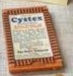The gin pills for the kidneys made by the National Drug and Chemical Co. Limited of Canada are used for backaches and fatigue. The dosage instructions for these are “take one or two pills four times a day, before or after meals and at bedtime”. They contain three eighths of a grain of methylene blue per maximum adult dose.

# The Princeton Hotel

The Princeton Hotel was housed in a rather substantial building; it was located on Bridge Street in the heart of the town, having first opened its doors in 1912. At the time, it was the only brick building in Princeton, consisting of 40 rooms, electric lighting and indoor plumbing. It was the last and most glamorous in a succession of hotels that played a key role in Princeton’s history. It also housed a licensed bar that would become the town’s longest continuously operating bar, with the exception of the prohibition years. Several businesses called the hotel home over the years, including the Bank of Montreal, the telephone offices, doctors' offices, restaurants, a tobacconist, a barber, a pub, and a retail liquor outlet. Hotels were one of the many industries that were affected by the building of the Hope-Princeton Highway. As the Kettle Valley Railway decreased in popularity, so too did the primary source of clientele, and as a result the hotel’s business dwindled. By the early 1950s, the hotel was renovated into suites that were rented out on a monthly basis. Sadly, the Princeton Hotel burned down in 2006, a fate shared by almost all of these historic hotels.

## The Switchboard

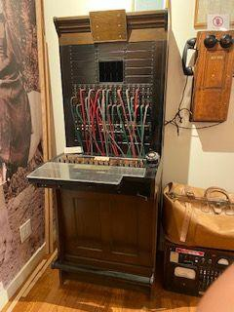The switchboard was Princeton’s first telephone exchange. This original switchboard was presented to the Princeton Museum by Eric Goodfellow in 1958. The original telephone office was in the early Howse building. It then moved to the Bell Block which housed a general store, a post office and a telephone. After Mr. Bell passed in

1925 the telephone office was moved to the Princeton Hotel which has unfortunately burned now, it stayed at the Princeton Hotel until it was later moved to Billiter avenue. The switchboard was used until automatic dial equipment was installed in 1965. We are told that the first telephone line in Princeton was simply just strung on trees. The 1907 report states that in the previous year $5,500 was put towards placing poles where trees were once used on the Nicola-Penticton section. There were nine phones on the line from Princeton to Penticton which were located at Stewart and McDonald sawmill, John Love and Bradley’s in Hedley, Richter and Kirby’s in

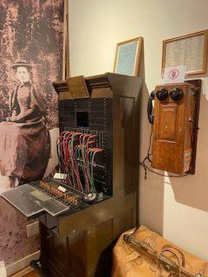Keremeos, one in Fairview at John Love and McCuddy’s, W.J. Snodgrass owned one in Okanagan Falls and J.A. Schubert owned one in Penticton. On May 16, 1956 the Similkameen Spotlight announced that a new project was being worked on, an installation of an additional position of switchboard and the rearrangement of central office equipment was being done so that there were four positions of switchboard available.

# Clothing Items

## Racoon Fur Coat

The racoon fur coat was donated to the museum by the owners of the Princeton Hotel. It was probably used on the stagecoach and then to transfer guests to and from the Train Station.

## Cotton Umbrella

The cotton umbrella is from circa early 1900s

## Stockings

These silk stockings are from circa 1940s

## Dress

The red turn of the century dress is from the 1900-20's

## Negligee

The white negligee is from circa 1949

# Ski Collection

Some items in this collection are from the Amber Ski hill and the Princeton Ski Club. Other items are more modern such as the 2 Slovenian Olympic team bibs from the 2010 Olympics that were donated as they trained in Princeton prior to the Olympics.

# Similkameen Star

## Letter Copying Press (Book Press)

This letter copying press is from circa 1900s. It was used by the Similkameen Star Newspaper in Princeton. These presses allowed numerous copies of a letter or paper to be made up to twenty-four hours after the original was written.

# The Welby Stagecoach

Story by Eric Jacobson, OHA 64: 104 - 105

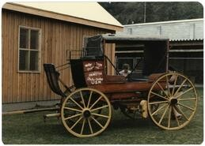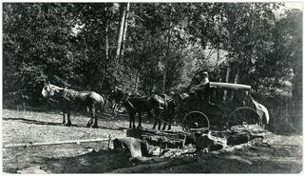In 1931, the coach stood in a shed owned by the F.P. Cook estate, located very close to the Tulameen River. Perley Russel was the store operator and in charge of the buildings. The vehicle was then moved, probably due to high waters, to a spot behind the Tulameen Hotel and stood in the open for many years. Reverend John Goodfellow purchased the stagecoach from Perley to ensure it would be preserved and then sold the Stagecoach to

the Village of Princeton for one dollar. Sometime around 1965 the Princeton Chamber of Commerce decided to restore the stagecoach, Ernie Garrison played a large part in its restoration along with Adolf Jacobson who had Swedish woodworking

abilities. Norma and Mel Turner, of Princeton Dry Cleaners, donated the interior upholstery and provided a source of steam for the oak bending. The wheels on the Welby Stagecoach were the biggest challenge, one had rotted spokes and fellows needed rebuilding, the restoration preserved as much as possible. At one point it was shipped to Quesnel for some repairs, the original footboard was replaced and some wedging had been done on the left hind wheel. Brass lamps had been added although they were not original. The left hind wheel was totally rebuilt in 1965 except for the hub. Each wheel was then given a “hot linseed oil treatment”.

# First Television in Princeton

In 1959, Sam Gould and Bob Bond used this TV and a generator in a truck to find the television signal coming from Kelowna, after finding the signal, they built a repeater in

that location and beamed the signal into town. Through Sam’s efforts, Princeton had

T.V. before communities much larger. The signal was picked up above Snow patch and beamed into Princeton from CHBC-TV. Sam and Bob spent months trying to find the best location to erect a satellite. Princeton Television was later established with John Ewart and Sam as partners.

# Wooden Water Pipe

In the early 20th century wooden pipe was often laid as a low-cost alternative to copper or concrete systems across North America. The wooden pipes were superior to the system of hollowed out log pipes used in England during the 17th and 18th centuries. This water pipe would have been installed in Princeton's first water line which was owned and operated by Mercer Murray before the village of Princeton assumed maintenance responsibilities. This particular piece of pipe is part of an elbow, to turn a corner.

# Large Wheel

The large wheel can currently be found in the outside storage. It was donated to the museum by Ed Cook after being found at the Twin Bridges, the old G.N. Bridge. It is said to be a wrench to put on and tighten nuts and bolts.

# The Allison Gun

The 987.46 HBC musket belonged to John Fall Allison; he used it while surveying Allison Pass.

# Steamer Trunk

Steamer trunks were mainly used from the 1800’s to the early 1900’s for the transportation of the most prized possessions of families. Oftentimes these possessions needed to be transported overseas or by steam train across large distances creating the need for these durable trunks.

# Projection Lantern

The projection lantern was developed in the 1940’s to promote education in remote locations. Film strips or slides could be used to project images onto a screen.

# Master Clock from International Business Machines Corporation (IBM)

The main function of this ‘master’ clock is to keep numerous accurate ‘slave’ clocks in various locations, all at exactly the same time. To accomplish this, the master clock sends a signal, in the form of a powerful Direct Current pulse to the slave clocks every minute. An optional program controller could be added which provided Alternative Current power signals to the slave clocks to ring bells or buzzers at certain times to signal important events, such as the beginning of class.

# Granby Power Plant Bricks

The brick wall located in the museum is made of bricks from the Granby Power Plant. Photos exist of the old power plant (PRIN002PPWR006/007/008).

# Hunter Desk

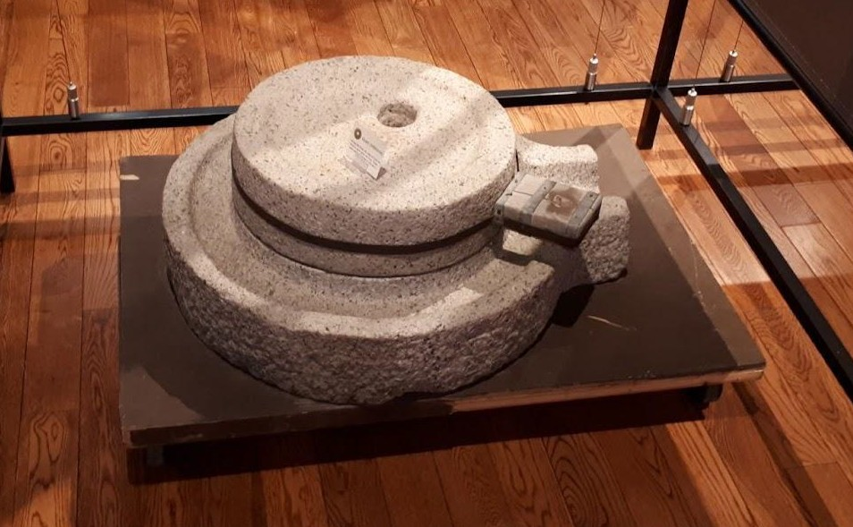The Hugh Hunter desk is an English Victorian roll top oak desk (Photo #122). Hugh Hunter was a local pioneer. He was a Government Agent and School Trustee; he negotiated the deal for the old school grounds which was originally owned by John Allison from the Government for the price of $1.00.

# Quern (Millstones)

These two opposite stones form a grinding device when the top stone is rotated. The bottom stone is called the Quern and the top stone is the Muller.

These devices have been used around the world to

grind grain into flour and for processing nuts, seeds, fruits, vegetables, herbs, spices, meat and pigments. The oldest Quern found is nearly 30,000 years old.

# Milkshake Machine

## No. 9K28I72, $9.60

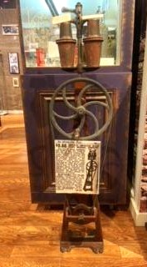The imperial noiseless milkshake machine was sold for $9.60. “Buy one of these machines and make it pay for itself in one day at

your county fair. It is handsomely painted, has nickel plated trimmings and glass caps for tumblers. It can be securely fastened to the floor, and does not shake the counter. This machine will soon pay for itself as it takes less milk to make milkshakes with it than it does by hand. One-half dozen tumblers furnished with each shaker, and directions for making syrups included. Weight packed for shipment, 74 pounds. No. 9K29661 price, $9.60. Same construction as No. 9K29661,

except the stands are made to be used on counters or bars, and requires little room. Packed complete with one half dozen tumblers. Directions for making syrups with each machine. Weight packed for shipment, 43lbs. No. 9K29660 price complete, $6.65”. The Milkshake machine was from the Granite Creek Hotel.

# 1925 McLagan Phonograph

This phonograph was made in Stratford Ontario. It has a special tonearm mechanism to produce superior sound.

# RCMP Buffalo Coat

The RCMP Buffalo Coat was donated to the museum by Craig Stout in 2016.

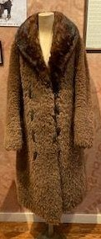This buffalo coat was part of the cold-weather uniform of the Royal Canadian Mounted Police, along with a fur cap, and long woolen stockings. In 1931 it replaced the cowhide and horsehide coats that had been worn from 1873, and was itself retired in favor of the nylon parka in 1954. Each coat required its own buffalo hide, bought by the RCMP for $13 apiece. About 65 hides were purchased per year while the coats were being issued, then tailored by Montreal furriers for around

$90 per coat. Coats of caribou skin or heavy Hudson’s Bay Co. wool were favored to the buffalo coat in northern postings. However, the RCMP, as demonstrated by its continued use in ceremonial settings, including by guards on Parliament Hill in Ottawa.

# Hardcastle Pipes

Hardcastle was founded in 1903 by Edmund Hardcastle, and was known as a reputable manufacturer of mid-grade pipes. The pipes were used for smoking. In 1946, all Hardcastle shares were bought by Dunhill, turning Hardcastle into a 100% Dunhill subsidiary until 1967, when Dunhill merged Hardcastle with Parker.

# Prince Albert Tobacco

Prince Albert was one of the more popular independent brands of pipe tobacco and cigars in the United States and was available in 1.5 oz pouches or 14 oz tins. The tobacco was personally named R.J. Reynolds after Edward VII, who was known as Prince Albert before being crowned King.

# Map: Sgt. William McColl in British Columbia

Senior surveyor with the Royal Engineers of England and of the Columbia Detachment of the Royal Engineers of British Columbia.

**1858:** Born in Scotland May 24, 1819, Sgt. McColl volunteered for duty in the new colony of British Columbia. He travelled on the ship “La Plata” arrived in Victoria October 29, 1858, he was present at Fort Langley when Judge Matthew Begbie was sworn in. He did extensive surveying and drew up a map of the Fort.

**1859:** He and his party moved to Sapperton. They surveyed the towns of New Westminster, Hope and Yale.

**1860:** He took to surveying and laying out of the trail from fort Hope to the Similkameen. Laid out the township of Princeton.

**1861:** He surveyed on the Fraser Canyon from Yale northwards – between Spuzzum and Chapman’s bar. He chose the site for the Alexander Bridge.

**1862:** The building of the Caribou Road

**1863:** Sgt. McColl was surveying on Burrard inlet. Laid out three Townships: Quesnel

(2) and Barkerville. In 1863 the Royal Engineers in British Columbia were disbanded. Most of the men left, but Sgt. McColl chose to stay in British Columbia. He went into partnership with George Turner R.E. in New Westminster and then was the collector of the tolls on the Alexandra Bridge until his death June 3, 1865, at the age of 46. He left a widow and six children.

# Driller’s Rock or Hol(e)stone

## From OHS, 64: 106 - 107

Close examination of **Driller’s Rock** located between the livery stable and the museum will reveal some holes drilled at an angle down into the rock. There also seems to be a portion of the rock missing, and the whole boulder has suffered a crack, splitting it in half. This rock forms parts of the mining history in Princeton, Hedley and many other mining communities in British Columbia as well as areas in Washington, Idaho and Montana. Most mining operations were carried out by the use of hand drills of various lengths which were driven into the rocks by force of a sledge hammer wielded by another miner as the drill man twisted the bit to give a cutting motion to the rod. This was used in order for hardrock miners to provide holes in which dynamite was placed prior to blasting the ore body. As far as can be established this rock was used for a competition held in Princeton on July 13, 1913. At that time the rock was located in the triangle formed by Halliford and Vermilion Ave on private property. A wooden platform was built to cover most of the rock, providing a stage for drillers and officials to stand on during the competition. The contest held on July 13, 1913 had a top prize of $500 with smaller amounts for second and third place. The object was to see which team could drill the deepest hole in 15 minutes, following the changing of positions after the first and second minute and 30 seconds thereafter with a timekeeper calling out the time for each change of position, coordination was the key to winning.

The rock stayed here until the spot was damaged during the 1987 sidewalk installation. The owners of the property, Jack and Mary Broderick donated this rock to the museum and the town crew moved it to its present location.

More information on the other 6 stones under *Stories From the Area*

**Museum History**

**Information from Rosemary Crawford**

**Founders: Mrs. Isobel Howse, Mrs. R. Stout, Rosemary Pesut**

In February of 1958 Gloria Stout suggested the start of a pioneer museum in Princeton with the opening date of May 24th as that was always the first big tourist weekend in the interior of the province. After deciding to take this project on Mrs. Isobel Howse, Mrs. R. Stout, and Rosemary Pesut needed a location, so they approached Mr. Elmer Burr who owned a vacant lot in the center of town, and he immediately agreed to let them use it.

After finding the location the museum was going to be set up their next step was finding a suitable building. They decided they wanted to use a log cabin as they felt it suited the name, this resulted in them searching for a cabin in the surrounding hills of Princeton.

After one was located, they were awarded $100 from the Centennial Committee in order to move it onto the lot. The cabin required some work, which Tom Stout and a group of volunteers were willing to help with, it needed new lower logs, a roof, floor, doors, windows and to be wired for electricity. While the museum was being set up it was time to advertise its grand opening, after writing a letter to C.B.C. radio they got an in-person invitation and while they were down on the coast, they complained to the Vancouver Sun that Princeton gets no publicity, so they also wrote an article after the opening.

Many people donated and loaned items to the museum in hopes of seeing it succeed and it did, almost 9,000 people signed the guest book that summer. As September hit the items that were loaned were given back and the items that were staying were secured until the following year. Premier W.A.C. Bennett awarded them certificates in appreciation for their contribution to B.C.’s centennial year.

# Stories From the Area

## Meaning of “Similkameen”

Similkameen is the name given to our valley. It has been spelled many ways over the years. At first it was “Similkamough”. Father La Joune (an early priest) refers to “Tsemel-ka-meh”. One authority (Teit) says it means “eagle people”, named because eagles were plentiful in the valley. It is said to have originated from the Similkameigh indigenous people of the region, meaning “treacherous waters”.

## Naming Princeton

Princeton lies in a “V” shaped area formed by the emergence of the two rivers, the Similkameen and the Tulameen (formerly Vermilion). Dr. George M. Dawson, a Dominion geologist, suggested it should be called Vermilion River because of the reflection of the sun on the Red Bluffs. Vermilion is a native word for “Red Earth”. The name “Vermilion Forks” was adopted by the company that was first developed in the area. In 1860 when Governor James Douglas ordered the Royal Engineers to lay out the townsite it was originally called “Princetown” in honor of the Prince of Wales who had visited Eastern Canada in 1860. When the present townsite was surveyed into lots the name was transferred as Princeton.

## The Allison Family

John Fall Allison was born in Leeds in West Yorkshire in 1825 and passed away October 28, 1897. He first travelled to California then British Columbia in 1858 as part of the Fraser River Gold Rush. Allison was the first white settler in the area, he staked gold, copper and coal claims and established the first cattle ranch. John Fall was noted for his sterling character and was appointed a Justice of the Peace in 1876 along with being created first Gold Commissioner of the New Similkameen Mining District in response to the Tulameen Gold Rush at Granite Creek. He was married to first nations woman, Nora Yakumtikum and together they had three children. Nora was an industrious woman who ran a pack train for the Hudson’s Bay Company. John later married Susan Louisa Moir and together they had 14 children. When she passed away in 1928, she left behind her 14 children, sixty-five grandchildren and seventeen

great-grandchildren. There is a book written on her by Margaret Orms titled “A Pioneer Gentlewoman of British Columbia”. Today there are still many first nations and non-first nations Similkameen residents who trace their family lineage through John Fall Allison, Nora Yakumtikum and Susan Louisa Allison.

## First Explorers”

Vermilion Forks, present day Princeton, where the waters of the Similkameen and Tulameen Rivers meet, was an early stopover for the travelers passing to and from the West Coast along the trails of the Interior. The first white men to come were fur traders, in December 1812, Alexander Ross set out from Kamloops for Fort Okanagan (WA.) and decided to take “an unknown route in order to explore a part of the country they had not seen before”. Ross’s route was through the Similkameen Valley and was full of hardships which are described in his journal.

## Trails following establishment of Canada – U.S. border

Following the establishment of a Canada – U.S. border in 1846 it was necessary for the Hudson’s Bay Company to create an all-Canadian route from the Lower Mainland into the Interior. Alexander Caulfield Anderson was sent to find this new route which became known as the Brigade Trail and was completed in 1849. The trail began at Fort-Hope, crossed the eastern range of the Coast Mountains, past present-day Tulameen, down the Tulameen River and into present-day Princeton. The Whatcom Trail (1858) and Dewdney Trail (1860) followed and provided routes for fur from the Interior and for supplies to the few outposts in the Similkameen, Okanagan and Kettle River Valleys.

## Hudson Bay Brigade Heritage Trail: 1849

The passages through the mountains were first established to access the traditional hunting grounds of the Similkameen First Nations people. Blackeyes, the chief of the tribe often visited the area and led the first white men through the rugged country. This trail was one of the first overland routes to the interior that carried supplies inland and furs back to the coast. The Hudson Bay Company used the established paths as the main commerce routes in British Columbia from 1849 – 1861. Most of this area is still pristine and allows people the opportunity to experience nature in an undisturbed setting

while retracing the routes used by their forefathers. This section of trail is protected under the Heritage Act of British Columbia.

## Dewdney Trail: 1860 – Nora Yakumtikum, Re: HBC

“The Dewdney Trail (Originally named the Mule Road to the Interior) was one of the first trails to be engineered and built by contract in the newly formed Colony of British Columbia. The official contract was signed August 17th, 1860, between Richard Clement Moody, RE, Chief Commissioner of Lands and Works British Columbia and Edgar Dewdney of New Westminster (later to become Lieutenant Governor of the Northwest Territories and then of British Columbia). When completed in 1866, it was the main route for pack trains supplying the miners from Hope to Fort Steele. Sir James Douglas, Governor of British Columbia ordered a trail to be constructed to Vermilion Forks (Princeton) to connect the interior goldfields and the coast. It was to follow the Hudson Bay Company Fur Brigade Trail east out of Hope, join the Whatcom Trail at Snass Creek and go over the Punch Bowl to Tulameen. After Douglas traveled to Rock

Creek in September 1860, he decided to bypass Tulameen and head directly to Vermilion Forks via Whipsaw Creek. This trail was a vital link to the Interior of British Columbia and played a particularly important part in the early settlement of the colony of British Columbia. There are 36 kilometers of trail within the Cascade Recreation Area of Manning Provincial Park”.

## The Hope Pass Trail

The Hope Pass Trail was a 35-kilometre diversion of the Dewdney Trail that went up the Skaist River and down the Whipsaw, avoiding the steep canyon in Snass Creek. This section of trail was built shortly after the Dewdney Trail was completed to Princeton in 1861. The Royal Engineers constructed the trail in only three weeks with a budget of six thousand pounds sterling. The Hope Pass Trail was the most heavily used trail as it became the main corridor from Hope to the southern interior for more than a half century before the Hope-Princeton Highway replaced it. After the 1860’s, the economic force behind trail building shifted from the gold rushes to general commercial trade and cattle and sheep drives.

## Bill Miner

<https://www.thecanadianencyclopedia.ca/en/article/william-miner>

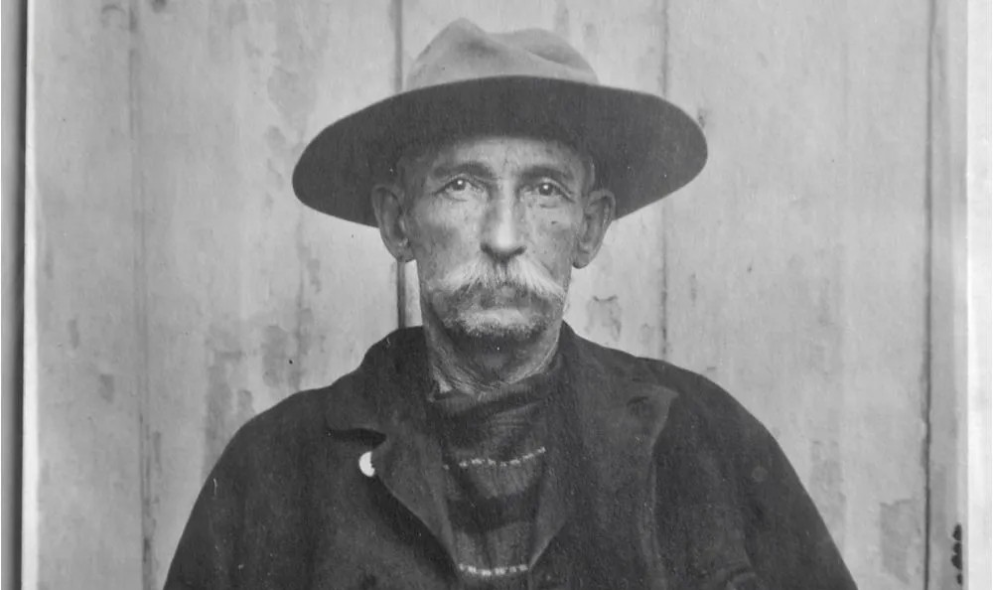Ezra Allen (Bill) Miner was born circa 1847 and passed away September 2, 1913. He was reputed to be the first train robber in Canada although bandits robbed a Great Western Railway October 13, 1874, 30 years before Miner arrived in Canada. He was the first to rob the Canadian Pacific Railway and became an outlaw hero in Canadian folklore. He was also known as the “The Grey Fox ''

and the “Gentleman Bandit” as he had polite

manners during his hold ups. He was also credited as being the outlaw who coined the phrase “Hands up!”. He gained notoriety as a road agent, robbing stagecoaches. His crimes resulted in him being incarcerated in California's San Quentin State Prison in 1866, 1871, 1872, and 1881. In 1881 he was sentenced to 25 years, in 1902 he was released. He briefly worked honest labor and then was back to his criminal ways, targeting trains as stagecoaches had disappeared. Bill Miner crossed in British Columbia in 1904 and posed as a semi-retired rancher named George Edwards. On September 10, 1904, he held up CPR’s Transcontinental Express No. 1 a few kilometers west of Mission. Him and “Shorty” Dunn got away with $6,000 worth of gold dust, more than $900 in currency and $50,000 in US bonds. Miner fled from Canada after breaking out of the British Columbia Penitentiary and continued his career as a bandit until 1911 when he was arrested in Georgia for a train robbery, he was taken to prison where he passed away.

## Seven Stones of the Similkameen Princeton Our Valley Pg. 11, 12

There are seven different stones located within the Similkameen that all have different stories and legends behind them.

The **Rainstone**, situated in the Similkameen River, was located a little east of the original Allison home. According to legend, if it were struck by lightning it would cause rain to fall.

The **Witchstone** is found near the entrance of the old Dignan place at the base of a large tree. This stone has markings that suggest the prints of dancing feet, the First Nations people avoided this rock at nighttime, the traditions of witches may conjure up visions of dancing spirits around a boiling cauldron, it is quite likely this site was a meeting place for tribal discussions before the white man.

The **Ghoststone** was located around twenty miles north of Princeton on the One Mile or Merritt Road. You would come to the Ghoststone after walking 100 yards from the highway, after reconstruction of the road the site was buried under tons of debris.

According to Mr. Whitely there was a battle between the Nicolas and Similkameen fought here, the Nicolas were forced to retire and left many dead on the field.

Thousands of pieces of wood were placed as offerings for those who lost their lives. The **Firestone** is located between Princeton and Hedley, it had the peculiar property of giving off smoke by day and fire by night. It may also be a tribal memory going back to the time when there was an open volcanic vent in the area, which emitted columns of smoke by day and fire by night.

The **Lovestone** is a huge boulder with a square front over twenty feet in height and an upright staff on the top. Travelling east it is on the left side of the road between Hedley and Keremeos. According to a local legend the daughter of a Similkameen chief fell in love with a brave from another tribe. The chief frowned upon this. One night the chief

caught the young brave and was determined he would be put to his death the next day. The young maid swore she would ride to the top of the square rock if it would save her lover, the chief grunted and thought he knew it couldn’t be done. The young maiden successfully rode to the top of the rock and back down, the chief was so impressed he forgave the young brave and received into the family.

The **Leapstone** or Lovers Leap is the highest point on the road between Coalmont and Tulameen (The road now goes across the creek instead of up the Leapstone) where the road takes a sharp bend at the top of a long hill. There are several versions of the story, but all have much in common with the story of Lovers Leap which can be duplicated in the folklore of nearly every country.

The **Hol(e)stone** was located on the Thomas property across the road from the Princeton Court House. It is a relic of the days when rock drilling contests were a feature of every Dominion Day Celebration in the Similkameen. The stone is filled with holes caused by drilling contests and for this reason have been christened the “Hol(e)stone”. The stone is now situated on the Museum property.

## Chinese in Princeton

The Chinese have been a part of Princeton’s history since the earliest days. The first big wave of Chinese immigration to western Canada took place during the Fraser River (1858) and Cariboo (1861) Gold Rushes. The next big influx was the use of Chinese laborers in the building of the Canadian Pacific Railway in the 1880’s. The Granite Creek Gold Rush in 1885 brought another influx of Chinese. After the gold rushes were over and railway construction died down, many Chinese stayed on to continue placer mining or to set up business in the towns that were emerging. In 1891 the Chinese formed about 35% of the population of the Princeton area. By 1901 this dropped to 13%. The total population at that time could be counted in the hundred. By 1911 with the influx of more settlers the percentage of Chinese had slipped to about 4% and by 1918 with the population at about one thousand, there were 80 Chinese inhabitants (8%). By 1921 this had slipped to about 4%. Many of the Chinese stayed on to mine the very small quantities of gold left in the rivers and creeks that had already been exploited. Princeton's China Creek and China Ridge get their names from these miners. Those who weren't mining set up laundries, restaurants and other businesses. Almost all the Chinese in these early days were men. The financial and legal barriers to bringing wives and families to Canada were almost insurmountable. Smoking opium and playing games were some of the ways these early immigrants dulled their loneliness.

**“Friday” (Jang-Chong)** was born in Victoria; he was a bus driver and night clerk for the Princeton Hotel. He was brought to Princeton with “Old Sam”. “Friday” had a wife

nicknamed “Dynamite” and his uncle was Sam who worked as a steam engineer. Unfortunately, “Friday” passed away falling down the Princeton Hotel basement steps.

**“Old Sam”** worked as a night clerk at the Princeton Hotel and looked after the boiler. It is possible he came from the Nickel Plate Mine in Hedley. He then returned to China.

**“Wing” Senior (Kong Wing)** came to work for the Voight family at Voight’s camp, after this he then worked for the Bank of Commerce and later started Chicago Cafe (old Traveler’s Cafe). He bought the Jamieson’s (Wendell Sellers) ranch and brought his son from China, his wife still remained there.

**“Wing” Junior (Kwong Wing)** worked at the Princeton Hotel as a chambermaid after coming from China and later took over running the dining room for many years. He bought the Little Davenport Cafe, located in Hamilton Block between the Ewart’s store and the Butchers, from Harry Tuck. Wing Junior returned to China then came back to Vancouver, cooking in the Silver Dragon on East Hastings, his final destination is unknown.

## Similkameen Star Friday November 11, 1921, “Chinamen’s Luck*”*

“Hidden Treasure Recovered After Thirty Years”

“The old saying that you have to go away from home to get the news is borne out by the following items which appeared in the Weekly Dispatch, an English publication: Four Chinese, Ah Foo, Chew Lum, Ning Pam and Soo Key, who thirty years ago were miners prospecting in British Columbia, will shortly sail for China, each with a small fortune as the result of the increase in the price of platinum since the nineties. During their wanderings over the mining country in the Tulameen district they collected six pounds of platinum which, on breaking camp, they put into a saki bottle, and hid it under a slab of rock. Time separated the four and they were never able to return to their camp. But meeting again last year in China they decided to go back to Canada and recover their property, which they realized now represented a considerable sum of money, platinum having in the meanwhile gone up from 50 cents an ounce to $75.00. The intervening years had wrought many changes in the locality of their former wanderings, but after some difficulty the parity found their camp and recovered the precious bottle, the contents of which they have now sold for over 7,000 dollars. - Reuter.”

## British Columbia Provincial Police The Red Surge

The RCMP was formed in 1920 by the merger of the Royal Northwest Mounted Police (RNWMP, founded 1873) with the Dominion Police (founded 1868). The former was originally named the North-West Mounted Police (NWMP), and was given the Royal

prefix by King Edward VII in 1904. Much of the present-day organization's symbolism has been inherited from its days as the NWMP, including the distinctive Red Serge uniform, paramilitary heritage, and mythos as a frontier force. The Red Serge or the scarlet *Mountie* coat has been used since 1880, and refers to the jacket of the dress uniform of the Royal Canadian Mounted Police. It consists of a scarlet British-style military pattern tunic, complete with a high-neck collar. It is a symbol that is recognized worldwide.

## Royal Engineers

In 1858, 165 Royal Engineers were dispatched from England (bringing with them 32 wives and 34 children) to BC. The detachment was selected out of a large number of volunteers to include every trade, profession, and calling which might be useful in a young colony. In the Princeton area the Royal Engineer accomplishments included: the Dewdney Trail, Hope-Princeton highway and the townsite Princeton.

## A Brief History of the British Columbia Provincial Police

The first law enforcement body (territorial) west of the Great Lakes had its beginning in Old Fort Langley November 19, 1858, 15 years before the formation of the North West Mounted Police. The mainland colony of British Columbia was established with James Douglas as governor, Mathew Baillie Begbie as the first Supreme Court Judge and Chartres Brew as Chief Inspector of Police. Due to the discovery of gold on the Fraser River and the inrush of thousands of gold seekers this historic step was taken. It was indicated that the police force should be formed from people of the community and to organize the force Chartres Brew was appointed as Chief, he had served as Inspector with the Royal Irish Constabulary in Cork Ireland. From this beginning Brew’s sprinkling peace officer kept law and order wherever the miner

wandered, from the canyons of the Fraser up to Barkerville and as far east as Wildhorse Creek in the Kootenays. With a population of about 20,000 BC entered confederation in 1871 and the handful of colonial police became BC Provincial Police. In 1923, under the Commissionership of John H. McMullen, a complete reorganization of The Force came about which included new administrative divisions, semi-military ranks, new rates of pay, as well as a police training school and a mounted troop for riot duty and ceremonial occasions. The necessity for faster communication was met by introducing the first city to city police radio telegraph system in North America, so that instant contact could be made throughout the province and which was tied in with radio equipped cars and coastal patrol boats. HF radio equipment was designed and built-in police work shops.

By the 1920’s the sailor policemen were manning a fleet of gasoline-diesel motor launches operating over 5,000 miles of coastline. Chartres Brew died in 1870 and was

buried in Barkerville BC. After 92 years of devoted service the BC Provincial Police was absorbed into the Royal Canadian Mounted Police - Thus with a sense of pride and admiration the British Columbia Provincial Police Veterans Association has arranged this plaque in memory of the oldest territorial police organization in North America.

# Places and Buildings

## Blakeburn

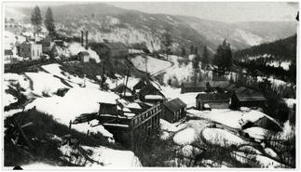Blakeburn was named after Vancouver businessman Blake Wilson and Calgary meat magnate Pat Burns in 1917. Coalmont Collieries Limited opened an underground coal mine at Blakeburn in 1914, at the peak of the operation there were 365 men employed. There was an underground mine explosion in No. 4 mine on August 13th, 1930, killing 45 men. Only one person survived from the afternoon shift, Johnny Porchello, he was only a few feet down the slope when the blast came and was able to get out. Most of the men survived the initial blast effect, some died of burns, others from rock falls and

asphyxiation overtook the rest as the mine roofs collapsed and blocked off the airways. Photo of Blakeburn in winter from this site. <https://arcabc.ca/islandora/object/princeton%3A1431>

## Copper Mountain

James Jameson was credited with discovering the copper mine at Copper Mountain in 1888, there was a major development of the property in 1924 when Granby Consolidated took over the mine and built a railway spur line to the site. In 1947 the company peaked and produced 5500 tons per day. In 1966 the mine was closed for the last time.

The town of Copper Mountain housed 600 people at its peak. In the story from Marilyn (Dunsmore) Strilchuk (in POV Pg. 141) she talks about living at Copper Mountain and the many hours of playtime she experienced. The school at Copper Mountain had grades from 1-7 leaving the older students to be sent by bus to Princeton Secondary School. There was a Community Hall that housed Cubs, Brownies, Guides and Scouts as well as movies. Within the town of Copper Mountain there were two churches, the United Church which John Goodfellow commuted to every Sunday from Princeton and the Catholic Church. Other buildings that could be found at the town of Copper Mountain were the general store, the post office, the bank, the public library and the pool hall which was run by Vince Quinn, he had a concession area where he sold snacks, sundries and magazines. The homes and buildings in Copper Mountain were heated with steam, at intervals through the town there were “Steam Boxes” which were used for access to the system.

## Granite Creek

The discovery of gold by John Chance at Granite Creek in 1885 redirected interest from fur trading to mining. Built by miners searching for gold, the town is a testament to early British Columbia mining history. Two thousand people participated in the gold rush at Granite Creek and it was the third largest center of population in the province at that time. The banks of Granite Creek below the Town Site would have been a hive of activity as miners searched for gold. This historic place is representative of an important moment in the continuum of the mining industry of the area. Gold mining in the area brought with it the discovery of platinum and later coal. Subsequently, the discovery of coal precipitated the development of the towns of Blakeburn, Coalmont and Tulameen. The Town Site is notable for having had a significant Chinese population located in the northeastern portion of the town. Although the Granite Creek Cemetery is valued as the final resting place for many of the pioneers, the Chinese section in the cemetery, which lies to the south of the main portion, reflects the segregation of the Chinese from the white miners. It is notable that depressions in the ground are evidence of the practice of exhuming graves and returning the remains to China. By 1910 Granite Creek was panned out and by 1911 Granite Creek became a ghost town, it was ravaged by fire and abandoned for more lucrative gold fields.

## Coalmont

After the Granite Creek gold disappeared miners turned to the coal in the mountains behind Coalmont for employment. It got its name from The Columbia Coal and Coke Company in 1911 who once advertised it as the City of Destiny. In the 1930’s and early 1940s Coalmont became a ghost town after coal mining in the area came to an end.

Today around 100 people continue to call Coalmont their home.

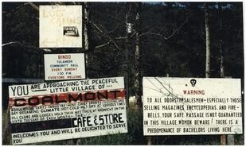 Picture from this site; <https://arcabc.ca/islandora/object/princeton%3Aphotographs?page=49>

## Tulameen

The history of Tulameen is traced all the way back to the Hudson’s Bay Brigade Trail as this passed through the area in 1846. In 1901, 55 lots in Tulameen were sold, averaging at $86 each. During the peak of Granite Creek, Tulameen provided prospectors and miners a place to relax. Around 250 people continue to live in Tulameen today. Many people from Copper Mountain had cabins in Tulameen. There was a store on the beach

called “Annie’s Store” and the general store called “Squelch’s Store”, which was located where the trading post now sits.

## Hedley

Hedley bills itself as being famous for gold, and it is. The first-time gold was discovered in Hedley was in 1897 and a year later hundreds of claims were staked, the first rich one was credited to Duncan Woods. The Daly Reduction Company Limited was the first company to begin mining gold on Nickel Plate Mountain, when the mine closed in 1955 it had yielded an estimated 50 million dollars in revenue. In 1987 the mine was reopened as an open pit mine by Mascot Gold Mines Limited until it was finally closed in 1997. Many historic buildings can still be found in Hedley today.

## Other Ghost Towns

There were a number of other ghost towns located in the Princeton area. Allenby was the site of the concentrator that processed ore mined from Copper Mountain, this ore was transported on a rail line high above the Similkameen River. Allenby had a school, built in 1919 by the Canada Copper Co. as part of their Allenby townsite. It opened in 1920 with Mr. J.A. Price teaching 46 pupils. In 1927 there were 52 pupils so two teachers were hired. About 1941, the higher elementary grades were brought to Princeton by school bus. This left Allenby with only one teacher until September 1954 when a second teacher was engaged. The school closed in June 1957 because the Granby Mine closed.

Allison, Blackfoot and Leadville were other sites established in the area.

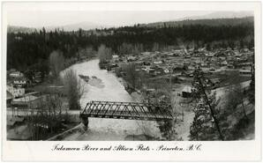**The Brown Bridge** was a crucial connection for Princeton in those days, leading to the Old Hedley Road, the

Princeton-Summerland Road, and of course up the Tulameen towards Granite Creek and beyond. It was destroyed by pack ice during winter-breakup and had to be replaced soon after. The second bridge was also destroyed, and now we're on the third bridge (1930).

Photo from this site; <https://arcabc.ca/islandora/object/princeton%3A903>